

**(Online)**

**ANL252 Python for Data Analytics**

# **Tutor-Marked Assignment**

**July 2021 Presentation**

**Submitted by:**

|  |  |
| --- | --- |
| **Name** | **PI No.** |
| **Muhammad Farhan Bin Saad** | **H1771425** |

**Tutorial Group: ­­­­­­­­­­­­ TV 09**

**Instructor’s Name: Mr. Kumar Munish**

**Submission Date: 08/08/2021**

**Question (a)**

In this TMA, we shall import the math package. The math package allows us to perform the mathematical functions required to answer the other questions.

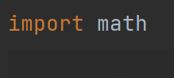

**Question (b)**

To answer question b and c, we are required to use the input function so that we can get the information from the user. To ensure the information can meet the conditions, we shall use the If statements.

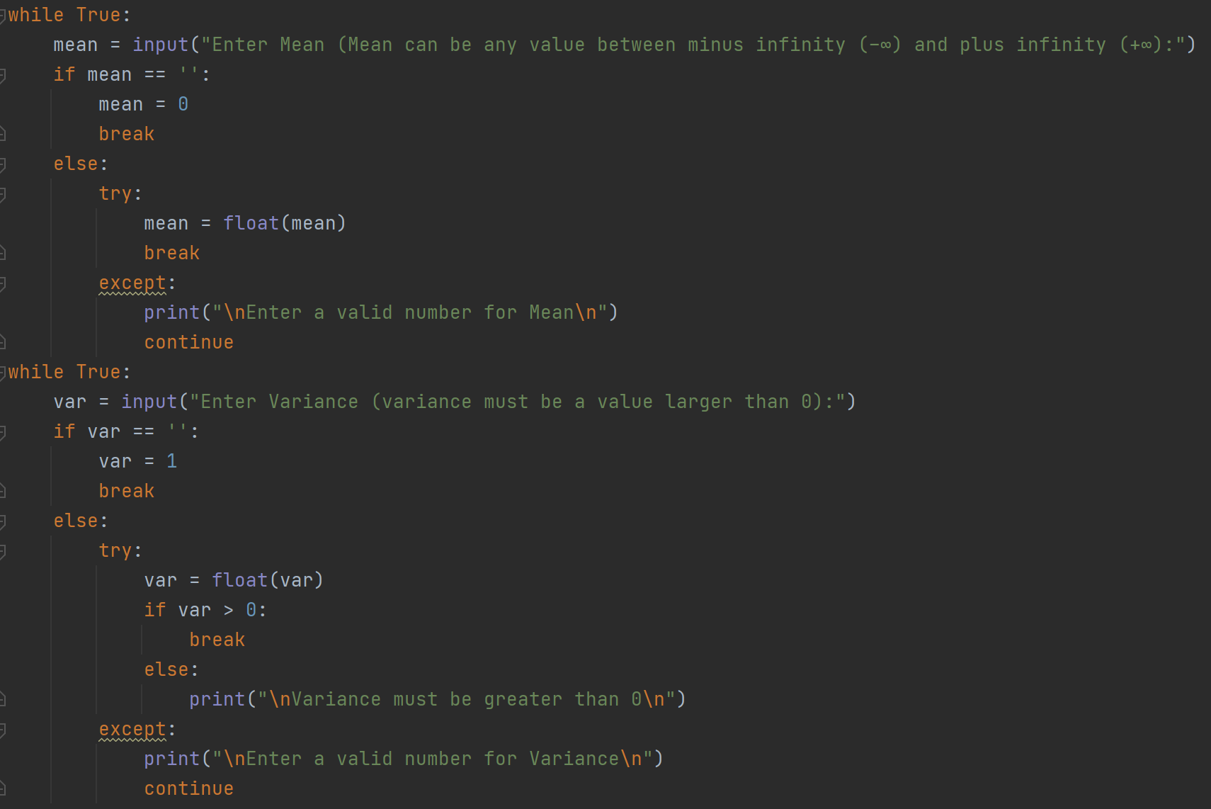

If the user enters the correct value of the input requirements it would look like below:

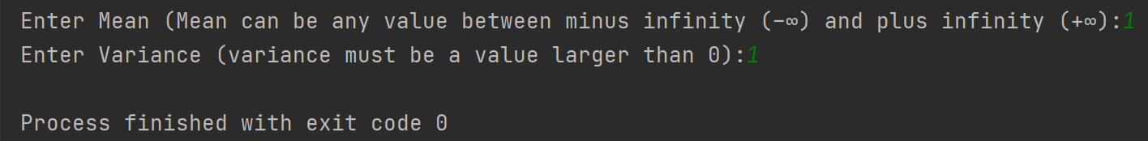

If the user provides the incorrect value of the input requirements, this program will prompt the user to enter the correct value again. Float allow user to enter any numbers including decimals. Hence this is used over integer. The use of break allows us to break out from the while loop and continue allow us to execute the remaining statement. Hence, as seen below this would result in prompting the user to reenter the correct values again.

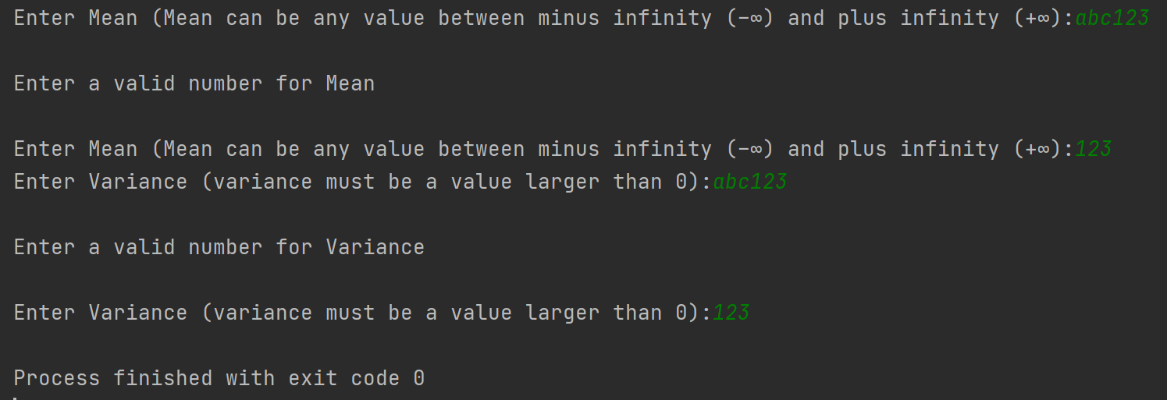

**Question C**

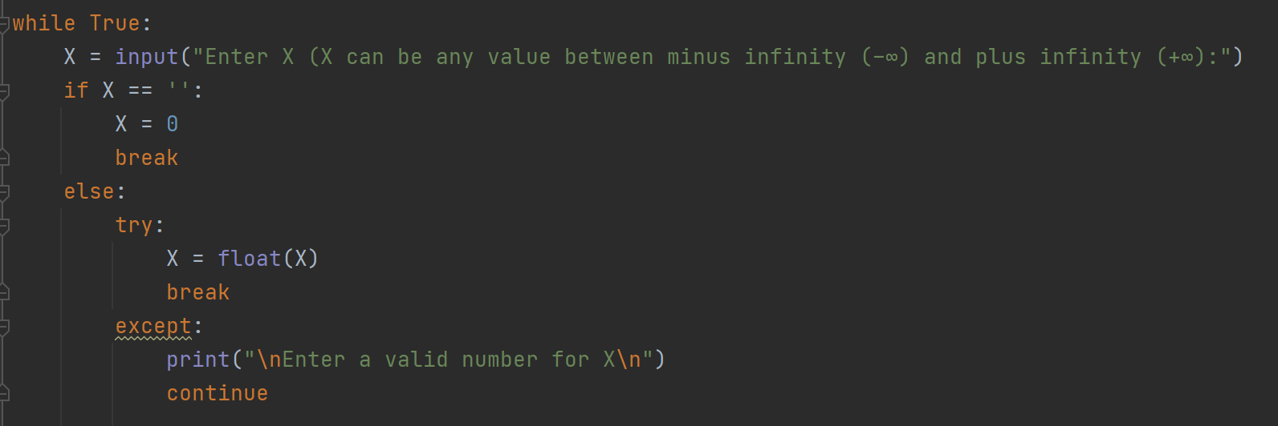

If the user enters the correct value of the input requirements of variable X it would look like below:

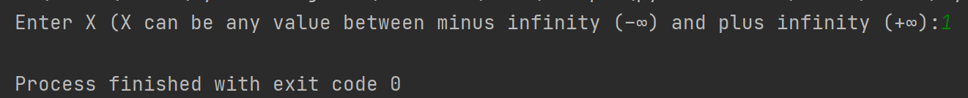

If the user enters the wrong value of the input requirement of variable X, the program will prompt the user to enter the value again. The wrong input will result the break function to kick in which break out of the while loop. Float is used to allow meeting the requirements which the value can be any which including decimals. Using float also prevent wrong inputs such as alphabets.

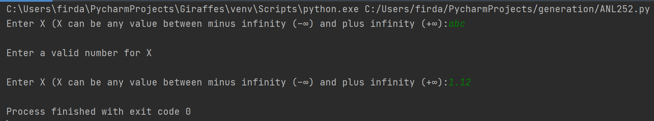

**Question D**

To answer this question, we must import math package to allow us to perform mathematical function such as math.pi, math. sqrt and lastly math.exp to create the mathematical calculation of the probability density function (Python 3.9.6, n.d.).

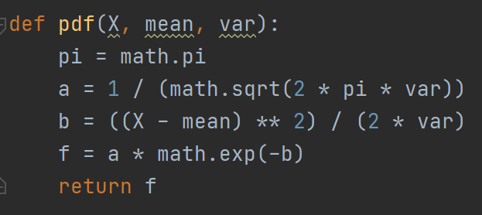

**Question E**

In this question, we are tasked to perform a formatted print. To do this, we shall begin a string with an f followed with a single quotation mark. Inside the {} is the variable that provide us the value of that variable.

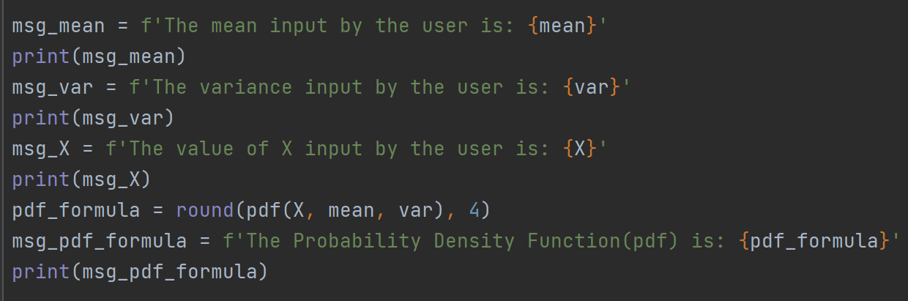

Output which is seen below.

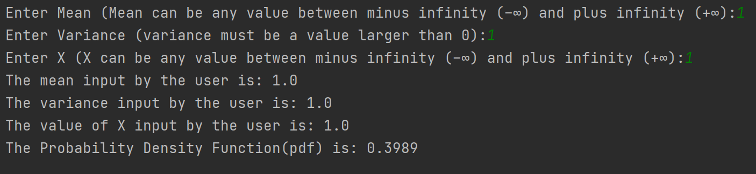

**Question F**

Python script of question F as seen below.

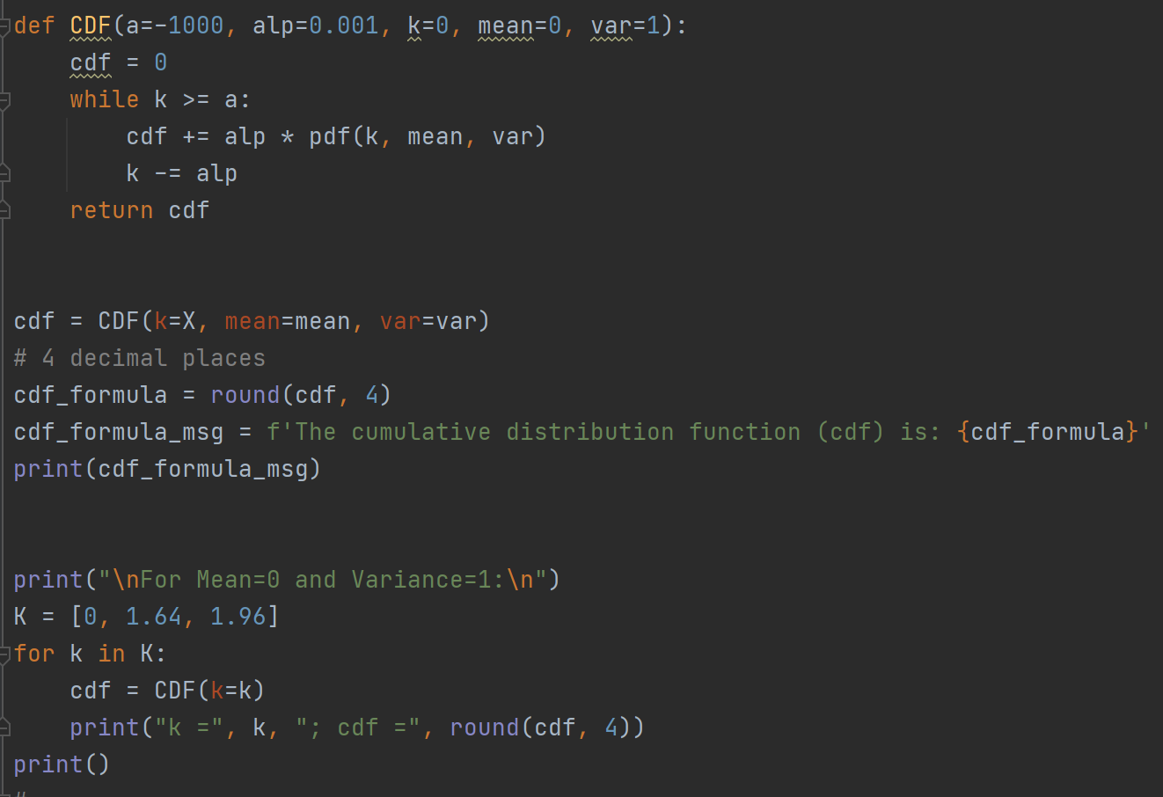

The output as seen below

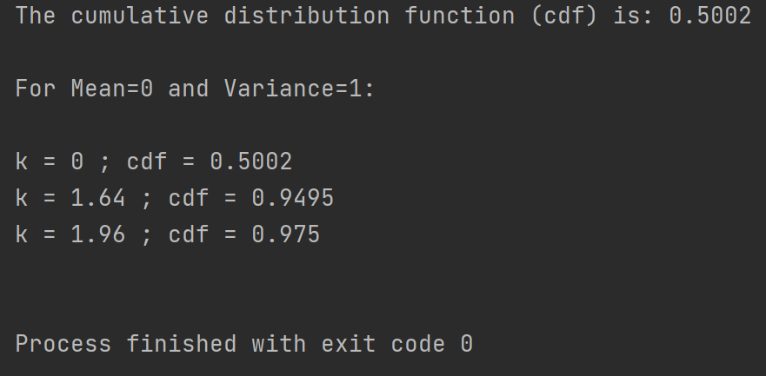

Question G

For calculating P(X ≤ k), we created a function CDF(a, alp, k, mean, var) where the value of the variable a was set to be equal to -1000 and the value of the variable alp (α) was chosen to be equal to 0.001 (for higher accuracy). Next the variable k was set to be equal to the X value that we have chosen in (c). Then a variable called cdf was initialized to 0 (which would act as the sum of all the pdf’s).

Then we ran a while loop which would break if the value of k becomes less than the value of a. Inside the while loop, we calculate the value of the pdf(k,mean,var) which was defined in (d) and we add this value to the value of cdf and lastly we decrement the value of k by α in each loop. Once the breaking condition is satisfied, we have the value of cumulative distribution function stored in the variable cdf.

Furthermore, we also checked the results for k = 0, 1.64, and 1.96 with a mean of 0 and variance of 1 as well. We obtained the following output for the same.

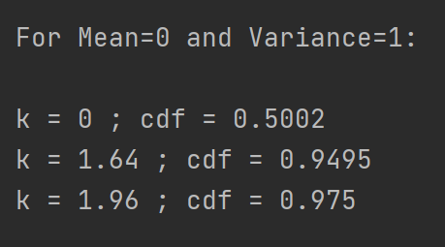

**Question H**

Python script of question H as seen below. To solve this question, we shall create an empty dictionary and create the variable as prob. We shall also create a list of all the probabilities. The reason we use list so that it is in order as we required the probability from -2 to 2. Lastly we shall use a while loop and if statement to run the program.

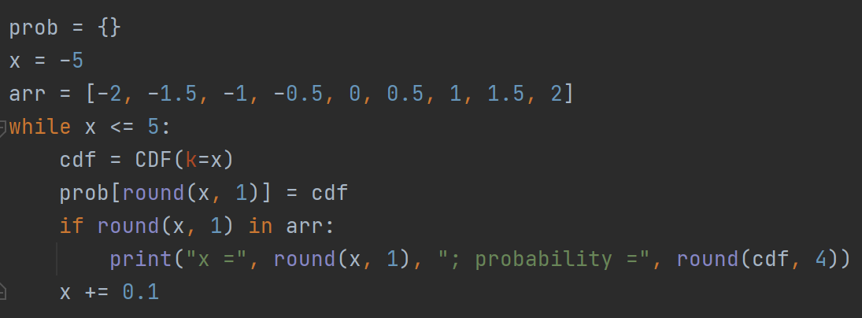

Output of the python script as seen below.

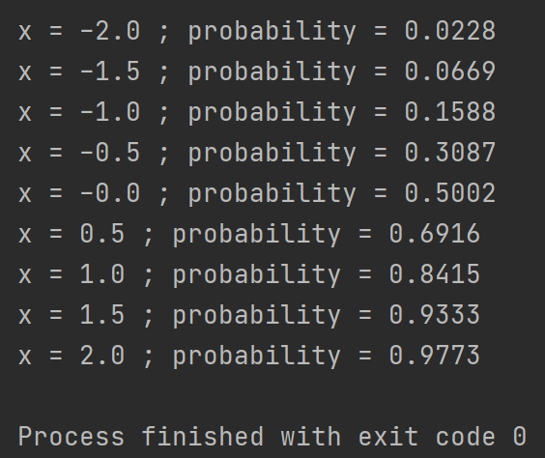



**END OF ASSIGNMENT**

# Works Cited

*Python 3.9.6*. (n.d.).

*math — Mathematical functions*. (2001-2021). Retrieved from python 3.9.6: https://docs.python.org/3/library/math.html

Mosh. (2019, Feb 18). *Python Tutorial - Python for Beginners [Full Course]*. Retrieved from Programming with Mosh: https://www.youtube.com/watch?v=_uQrJ0TkZlc

Wu, K. Y. (2021). *ANL252 Python for data analytics (study guide)*. Singapore University of Social Sciences. Release V1.0 Build S1.0.5, T1.5.21